Distance and Displacement
When we travel from one place to another we need to think about the Displacement and the Distance.
The displacement is the straight- line distance between where you start and where you finish.
The distance is the total length travelled by an object between the starting point and the finish point.
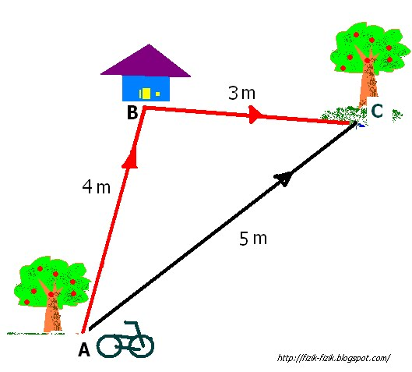
So in this diagram the bike rides from tree A to house B to tree C.
The distance it travelled was 7m (4m+3m).
Its displacement is 5m. Point A to C.
- In the diagram below state the motor bikes:
Displacement=_____________________
Total distance travelled=_____________________________
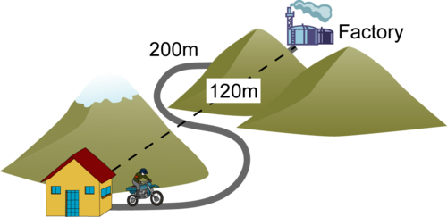

- In the diagram below state the bikes:
Displacement=_____________________
Total distance travelled=_____________________________
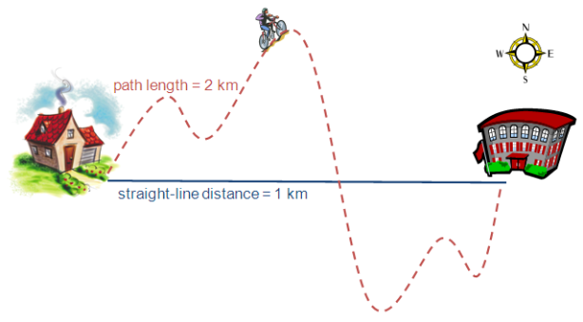
- Use a ruler to measure the displacement and string to measure the distance.
Displacement=_____________________
Total distance travelled=_____________________________

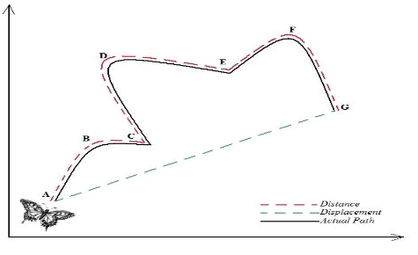
- 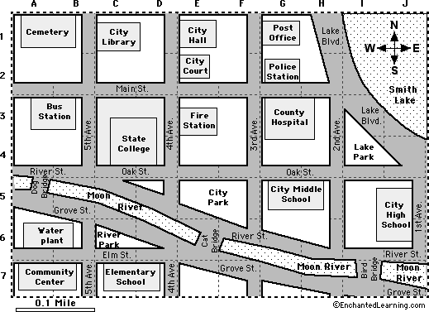
In the diagram above 1cm =1km

Start point | Finish point | Distance (km) | Displacemant (km)
A | B
A | C
B | D
A | D

